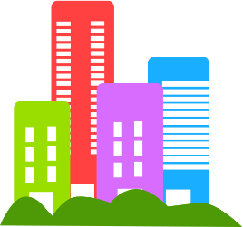
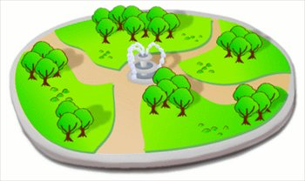
Community Contribution Report:

Your community is an example of a large and diverse group of people. For a community to be cohesive, everyone must work together and take into consideration all members.

You will act as a part of a local council and implement a new feature to your area. This could be in the form of something to be built, a program you could implement into existing facilities or an upgrade/addition to already existing facilities in your area.

This could include: a work of art to be commissioned, a skate park, a new kindergarten, English lessons for immigrants, a new park, swimming facilities, bus routes, a festival, station upgrades, road safety features etc.

You must consider why you are going to include this feature, what benefit it will bring to your community, how it will benefit the members of your diverse community, how much it will cost, any drawbacks that may arise and any other issues surrounding the feature.
Your assignment will be comprised of two things:
- A written report - detailing your idea.
- A visual representation of your idea to be incorporated into the report. This could be a drawing, 3D plans, a brochure, a poster, a model, photographs etc.

Brainstorm – Think of some possible ideas.

Which of the following things do you consider to be the most important or useful in a community?

Transport
Hospitals
Sport facilities
Art
Aged care
Recreation
Playgrounds
Natural spaces
Entertainment
Community centre
Festivals
Education
Roads
Waste management
Wildlife preservation
Childcare
Parks
Libraries
Common spaces
Safety

From the list above, you must choose a project that could be implemented into your community. Your project must:
- Include the needs of your diverse community.
- Be viable (this means it must be doable).

Use the report template and rubric on the following pages to help write your report. Your final submission on Compass should just include your report and visual representation.

Picture relevant to report

Community Contribution CAT
TITLE
NAME

Contents:
- Introduction
The purpose of this report is to present important information about my local area. This information will help me understand my area and the services/facilities that are available. Give general information about the community (specifics will be covered in the next section).

- Council Profile
- What suburb do you live in?
- What council it is part of?
- What is your council’s logo? Provide an example.
- What is your council’s boundary? (Include a map.)

- Council Demographic
Access the Quickstats from the ABS website. Search for the statistics about your council. Write a paragraph describing the population of your council. Include things like:
- How many people live in your council area?
- How many men and women there are.
- Average children per family.
- The most common ancestries in your area (where people are originally from).

- Your proposal
Explain your proposal and why you want to create it. Go into as much detail as you can about the proposed project.

- Community Benefit
How will your proposal benefit the community? Consider people from different cultures, religions and backgrounds. You may want to refer back to the data from the ABS website to support your claims.

- Viability
How viable is your idea in terms of general cost and ease of execution? Similar projects could be searched on the internet for comparison.

- Potential problems
Outline some potential problems you may face in completing your idea. How might you overcome these problems?
Strand | Sub strand | (A – A+)  18 months above | (B – B+)  6-17 months above | (C – C+)  AT LEVEL | (D – D+)  6 - 17 months below | (E – E+)  18 months below
Intercultural capability | Written explanation  Cultural diversity | Student is able to place project into a real world context using relevant data sourced from reliable organisations such as Australian Bureau of Statistics. | Explores how proposal will include various members of the community through consideration of cultural norms, religion and world views. | Student demonstrates research into culture and diversity of local community.  Proposal is explained in clear detail. | Student has considered community needs.  Proposal is explained. | Student lists community needs. | No evidence
Critical and Creative thinking | Written explanation  Reasoning | Written report justifies project viability using real world examples as comparison  in conjunction with relevant data collected from reliable sources. | Written report justifies project viability using relevant data collected from reliable sources.  Student is able to discuss potential problems and effective solutions. | Written report includes a justification of project in relation to community needs.  Student is able to discuss potential problems | Community needs are stated and explained with statement justifying choice.  Potential problems are mentioned. | Written explanation of idea outlines what will be introduced to community
Presentation | Visual representation |  | Visual representation follows conventions of plans such as blueprints, floor plans, or maps. | Develops visual representation and labels features relevant to written report. |  | Produces visual representation. | No evidence

